Installation Process for Oracle SQL Developer

Part A
Step 1: Download “ORACLEX112” and “SQLdeveloper” from below link
https://drive.google.com/drive/folders/1fRoN6RsUtoejHrr-gG8H4t1gPD1Ay2Hn?usp=sharing
--------------------------------------------------------------------------------------------------------------------------------------
Step 2 Extract files with help of WinRar (Download WinRar from google)
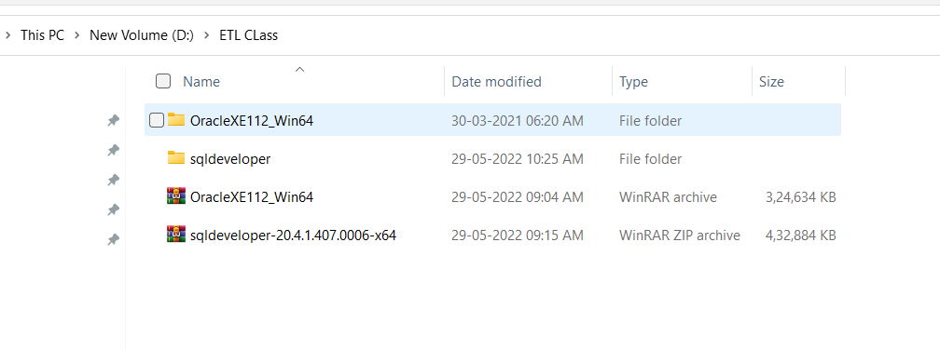
--------------------------------------------------------------------------------------------------------------------------------------Step 3 Double click on Setup from below path
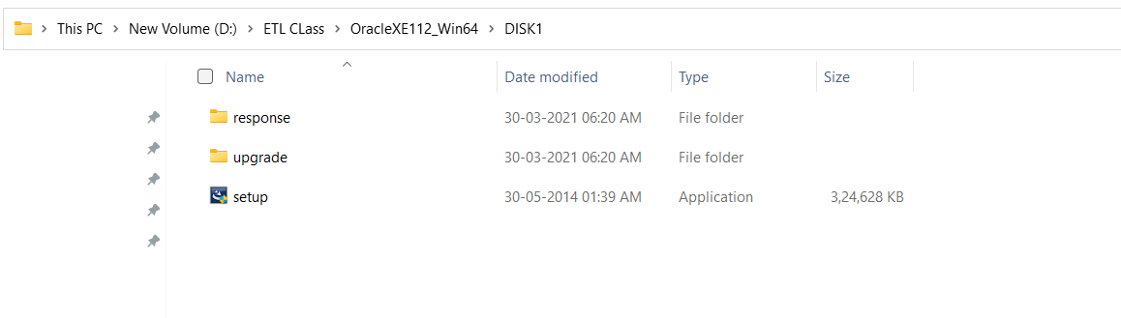
--------------------------------------------------------------------------------------------------------------------------------------
Step 4 In between process it will ask for password.
Enter password as “admin”. (You can choose different password).
Remember your password for SQLDeveloper options.
--------------------------------------------------------------------------------------------------------------------------------------
Step 5 Finish Installation by clicking on Next and Next.
--------------------------------------------------------------------------------------------------------------------------------------

Part B
Step 1: Double click on Sql Developer below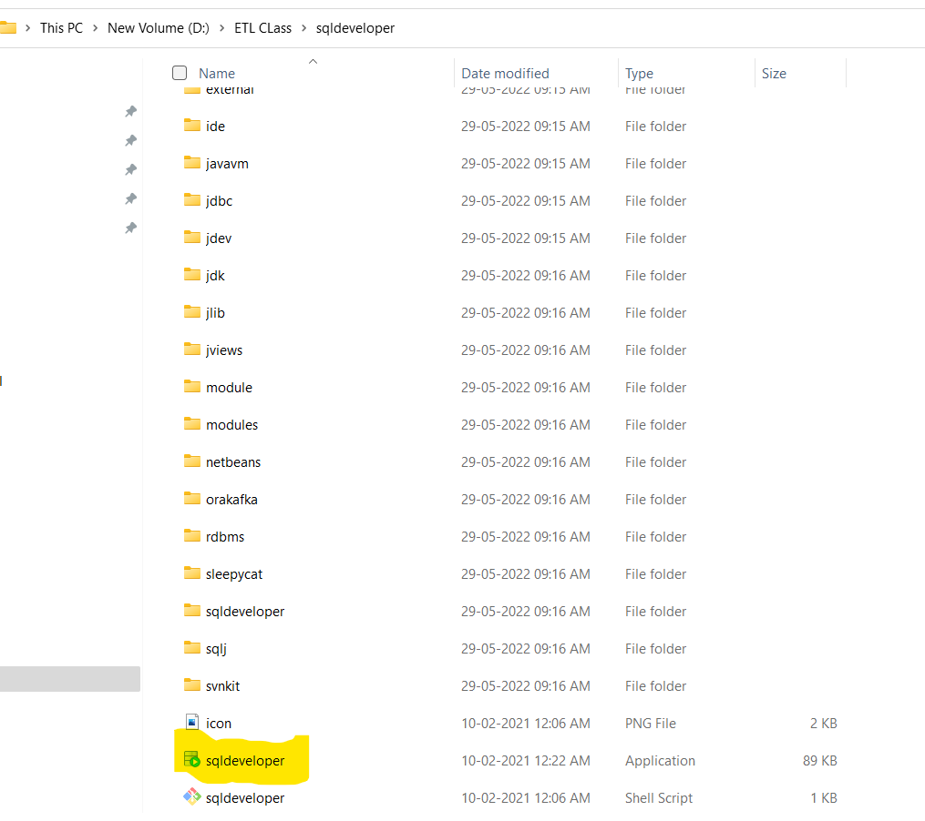
--------------------------------------------------------------------------------------------------------------------------------------
Step 2 Click on + button as shown below
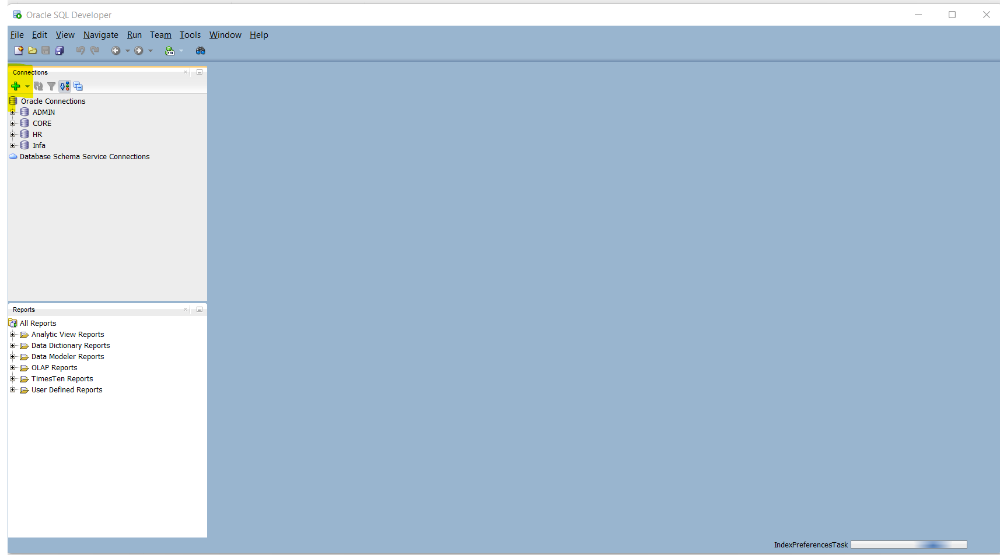

Step 3 After this new window should open Enter details as below (Password will be “admin” which we created in Part A of installation) and click on “Test” button.
IF Status: Success then click on connect.
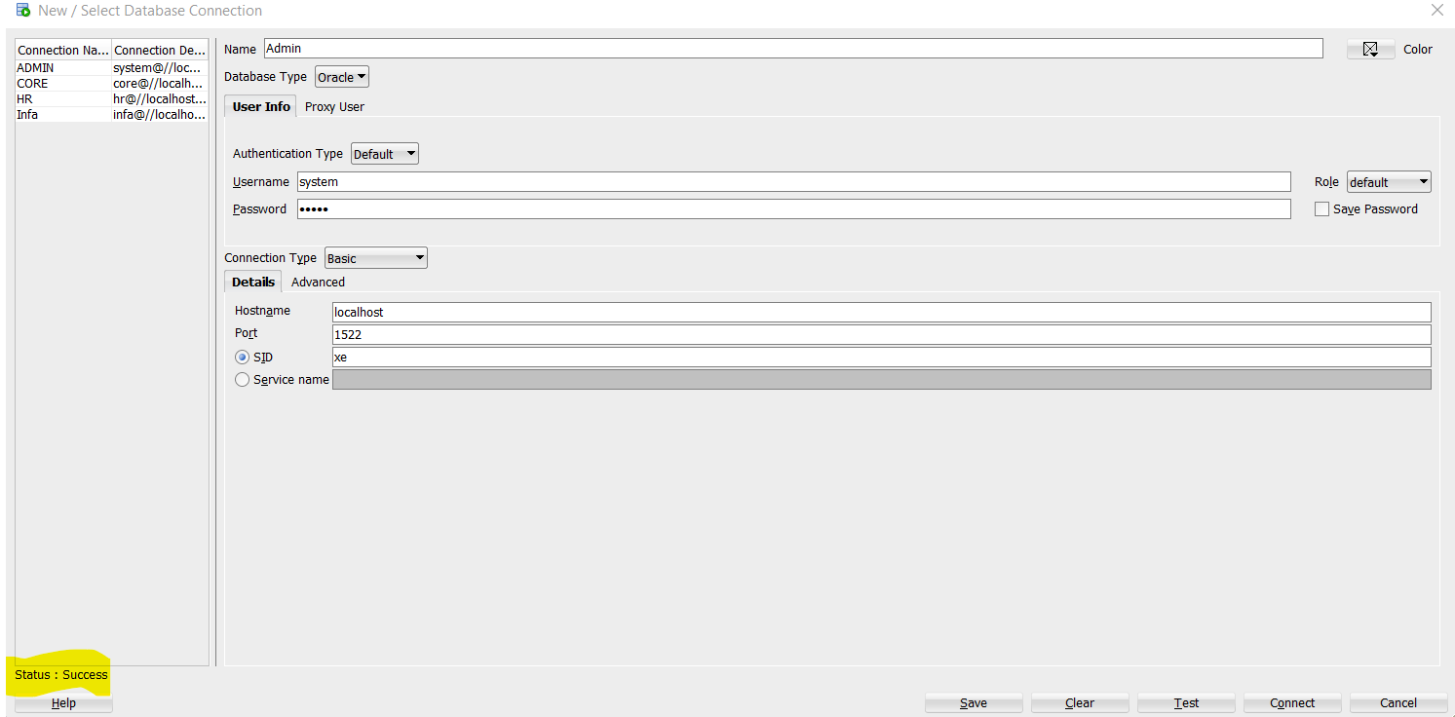
--------------------------------------------------------------------------------------------------------------------------------------
Step 4 New Worksheet will open as below, Copy paste below lines
ALTER USER hr IDENTIFIED BY hr account unlock;
create user infa IDENTIFIED by infa
grant dba to infa
create user core IDENTIFIED by core
grant connect,resource to core
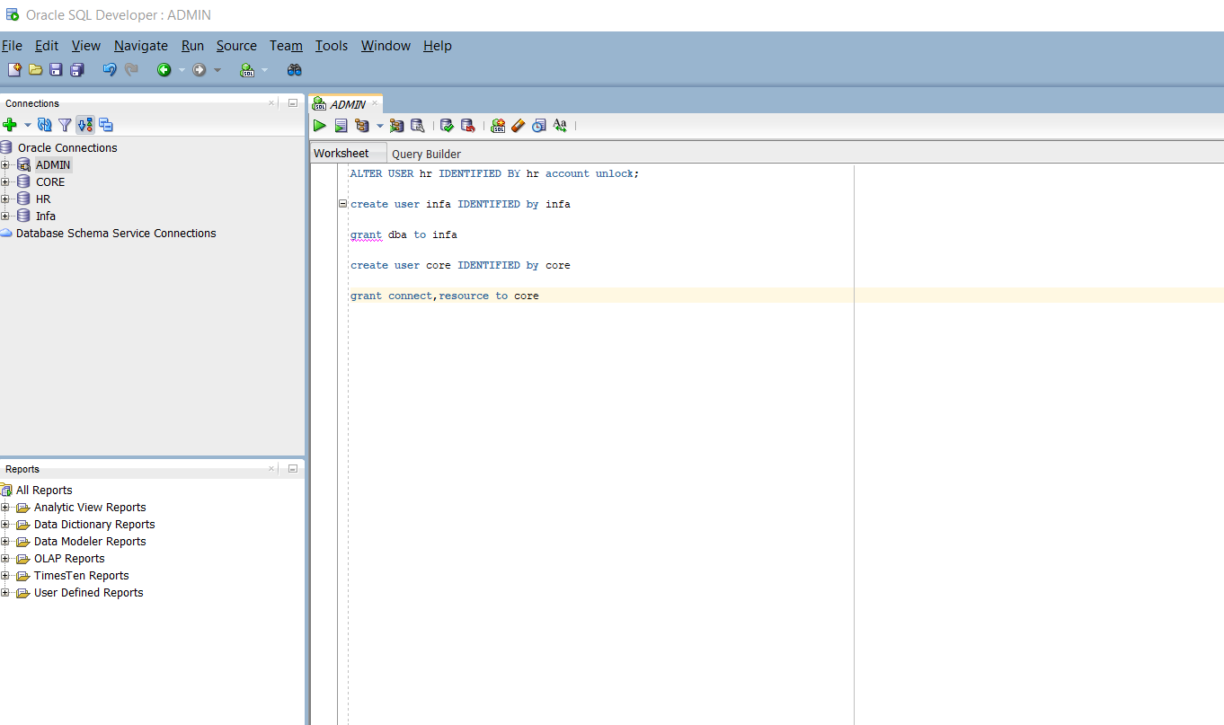
-------------------------------------------------------------------------------------------------------------------------------------
Step 5 Select all and click on Green “play” button highlighted below.
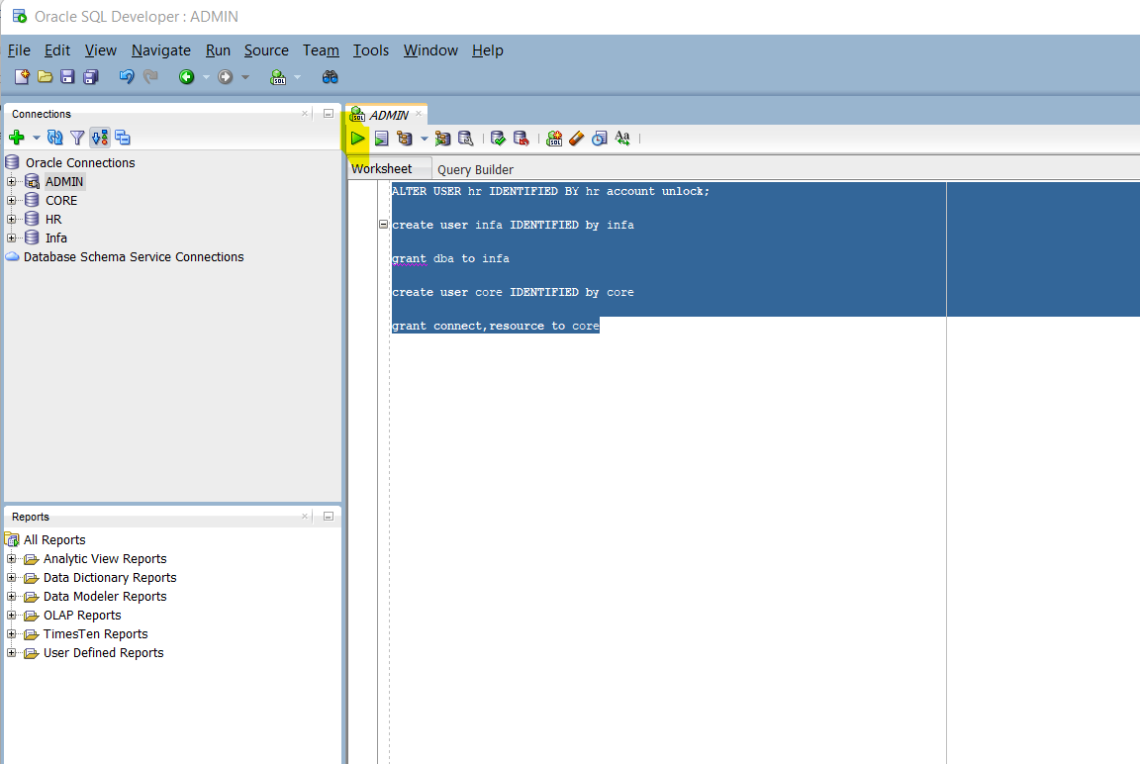
--------------------------------------------------------------------------------------------------------------------------------------
Step 6 Click on “+” button again
Enter details below Username as hr “and” Password as “hr”.
Click on Test and If Status: Success then click on Connect
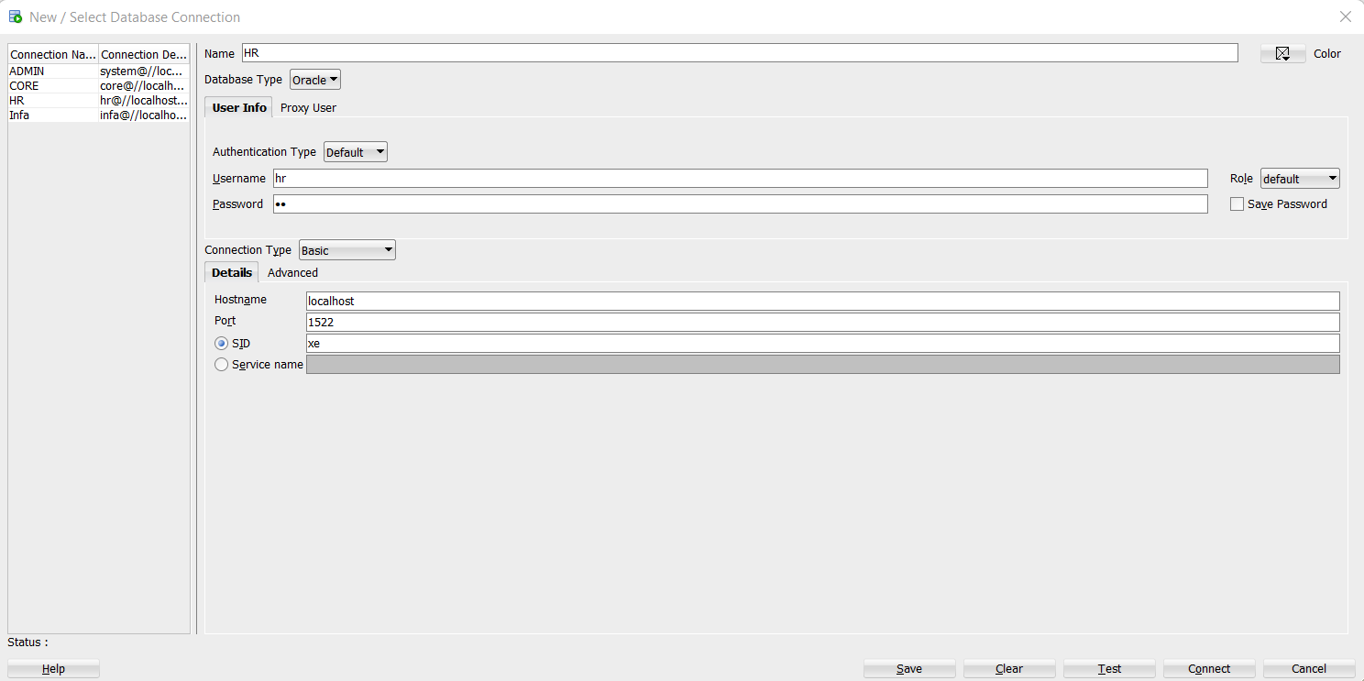

Step 7 Click on “+” button again
Enter details below Username as “infa” and Password as “infa”.
Click on Test and If Status: Success then click on Connect
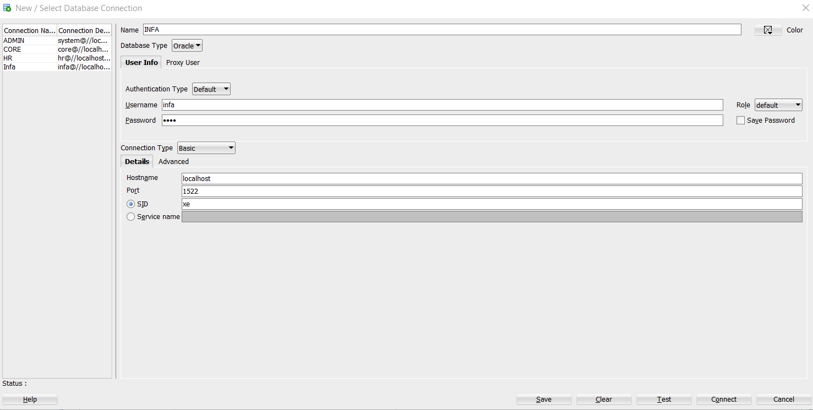
--------------------------------------------------------------------------------------------------------------------------------------
Step 8 Click on “+” button again
Enter details below Username as “core” and Password as “core”.
Click on Test and If Status: Success then click on Connect
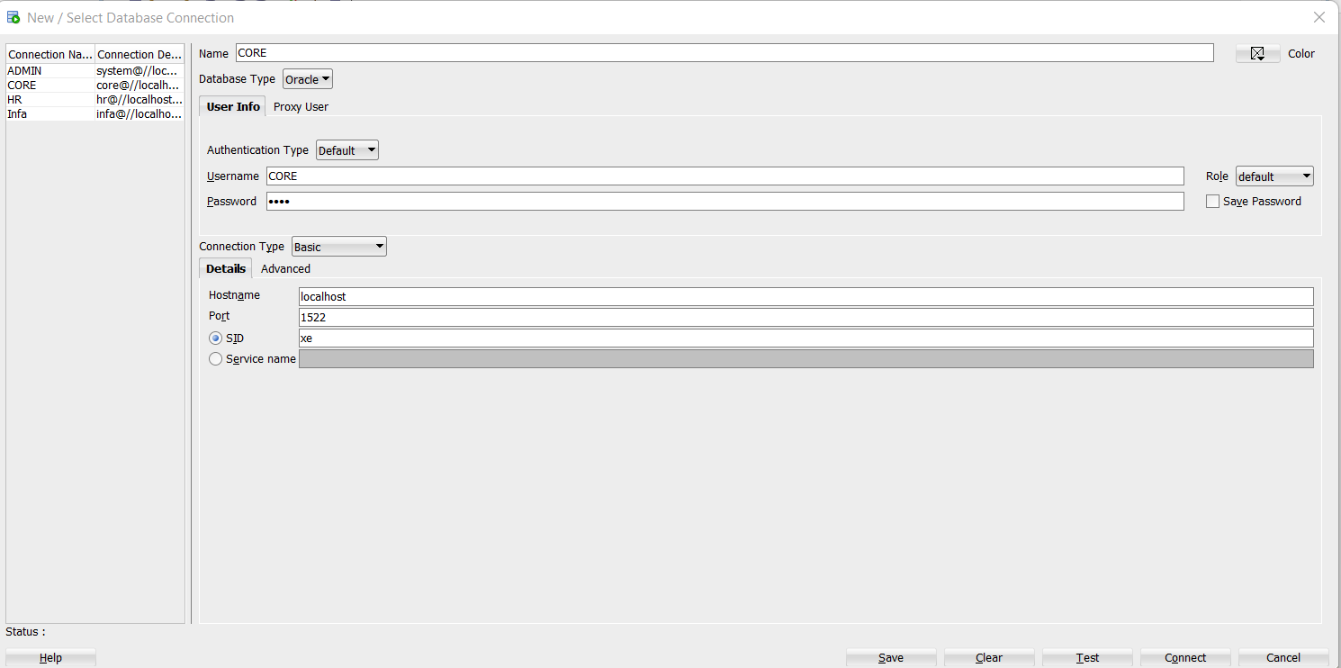
2--------------------------------------------------------------------------------------------------------------------------------------

